 

Project Initialization and Planning Phase

|  |  |
| --- | --- |
| Date | June 20h,2025 |
| Team ID | SWTID1750057522 |
| Project Name | Unlocking Silent Signals: Decoding Body Language with Mediapipe |
| Maximum Marks | 3 Marks |

**Define Problem Statements (Customer Problem Statement Template):**

Create a problem statement to understand your customer's point of view. The Customer Problem Statement template helps you focus on what matters to create experiences people will love. A well-articulated customer problem statement allows you and your team to find the ideal solution for your customers' challenges. Throughout the process, you’ll also be able to empathize with your customers, which helps you better understand how they perceive your product or service.

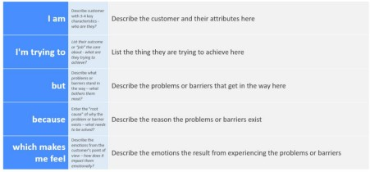

Reference: https://miro.com/templates/customer-problem-statement/

**Example:**



|  |  |  |  |  |  |
| --- | --- | --- | --- | --- | --- |
| **Problem Statement (PS)** | **I am (Customer)** | **I’m trying to** | **But** | **Because** | **Which makes me feel** |
| PS-1 | Individual (someone who wants to communicate better or be understood) | To convey my emotions or intentions more accurately | But I find it hard to express myself, or people misinterpret me | Because nonverbal signals can be misunderstood or missed | Frustrated, misunderstood, or powerless |
| PS-2 | Machine/robot (AI or service) | To respond appropriately to human signals | But it doesn’t “understand” body language | Because it mainly relies on voice or text | Ineffective, disconnected, or less helpful in human interaction |